Registration Form

registration period: until May 5, 2023

FES-Workshop / Event / Conference
Hambach Democracy Dialogue
14-16 June 2023 Hambach Castle
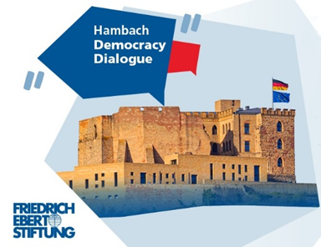
I hereby register for the above mentioned event.
Title:
Last name:
First name:
Date of birth:
Street:
Zip code:
City:
Phone:
E-mail:
Field of study / degree:

The participation is free of charge. During the workshop, as well as the conference, food and beverages will be provided by our catering service.

Motivation
- Why do I want to take part in the event “Hambach Democracy Dialogue”?

- Where do I see Europe in five years and what will have to be done to get there?

- What can I personally contribute, so that my vision can be fulfilled?

